User Defined Period Hook

This hook will work in conjunction with Enterprise version 4.31. It is to be implemented in 2 versions: one based on COM and the other as a 'straight' DLL in line with the pre-Delphi 5 hook implementation. The code will be distributed as part of the training materials available for third party hook developers.

There will be 2 components to the hook: a set-up module (a small executable) which will allow the end-user to define the dates by which a particular period is defined. Editing will be either by a right click mouse option or by an additional button to the right of the form. The user interface will look something like Figure 1.
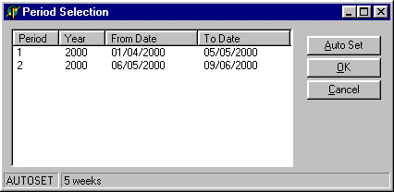

Figure 1

The user will be able to add periods and years into the list view with their associated start and end dates. There will be a maximum of 99 periods per year. The 'Auto Set' button will bring up a dialog as shown in Figure 2.
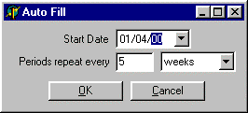

Figure 2
In this dialog the user will enter the start date and then a repeat period. In this case a repeat period of 5 weeks has been selected starting from the 1st April 2000. The first 2 entries this would generate are shown in Figure1. The number of entries generated would be sufficient to encompass a calendar year. If the 'Auto Set' option has been used the status bar will reflect this and show the value that was used to generate them. The main form will probably also have a "Clear" button. The user will be asked to confirm their choice if this is clicked. Double clicking on dates will bring up a standard Delphi date selection component as shown in Figure 3.
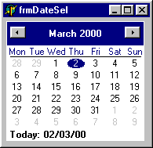
'OK' will accept all changes, 'Cancel' will ignore all changes. The values will be stored in an INI file, with a structure similar to the following:

Figure 3

[Periods]
; Key is PPYYYYA
; PP = period 01 to 99
; YY = 4 digit year
; A = letter, S = start date, E = End date

; Values are ddmmyyyy

012000S=01042000
012000E=05052000
022000S=06052000
022000E=09062000

When writing the set-up program will check that there are no gaps within the dates and if so the user will be warned. A simple print option could be added for the user's future reference?

The hook itself will simply return the period and year to Enterprise when called based on the date provided by checking it is within specific ranges stored in the INI file. If a date is out of range the hook could return the default period Enterprise would use, but this would entail the use of the Toolkit?

